# **UDM, Product Assignment**

## **Que: Backtracking round Gizmo product/**

**select**

*p*.PRODUCT_ID ,

*p*.INTERNAL_NAME,

*pcm*.PRODUCT_CATEGORY_ID ,

*pc*.PRODUCT_CATEGORY_TYPE_ID ,

*pcc*.PROD_CATALOG_ID,

*pcc*.PROD_CATALOG_CATEGORY_TYPE_ID,

*PS*.PRODUCT_STORE_ID ,

*ps*.STORE_NAME

**from**

product *p*

**join** product_category_member *pcm* **on**

*p*.PRODUCT_ID = *pcm*.PRODUCT_ID

**join** product_category *pc* **on**

*pcm*.PRODUCT_CATEGORY_ID = *pc*.PRODUCT_CATEGORY_ID

**join** prod_catalog_category *pcc* **on**

*pc*.PRODUCT_CATEGORY_ID = *pcc*.PRODUCT_CATEGORY_ID

**join** prod_catalog *pc2* **on**

*pc2*.PROD_CATALOG_ID = *pcc*.PROD_CATALOG_ID

**join** product_store_catalog *psc* **on**

*psc*.PROD_CATALOG_ID = *pcc*.PROD_CATALOG_ID

**join** product_store *ps* **on**

*psc*.PRODUCT_STORE_ID = *ps*.PRODUCT_STORE_ID

**where**

*p*.PRODUCT_ID = "GZ-2644";

## **Que: Create a product having no variant, we can purchase it, order it.**

1. Here I firstly create a product were i assign it unique product id with its productTypeId

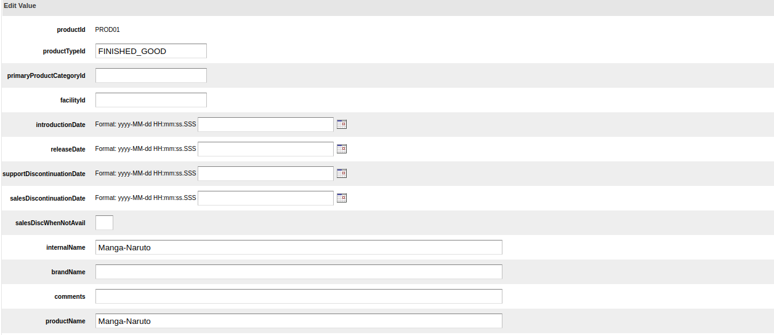

1. After creating product, i assign its category where i give its unique productCategoryId and productCategoryTypeId with the image url

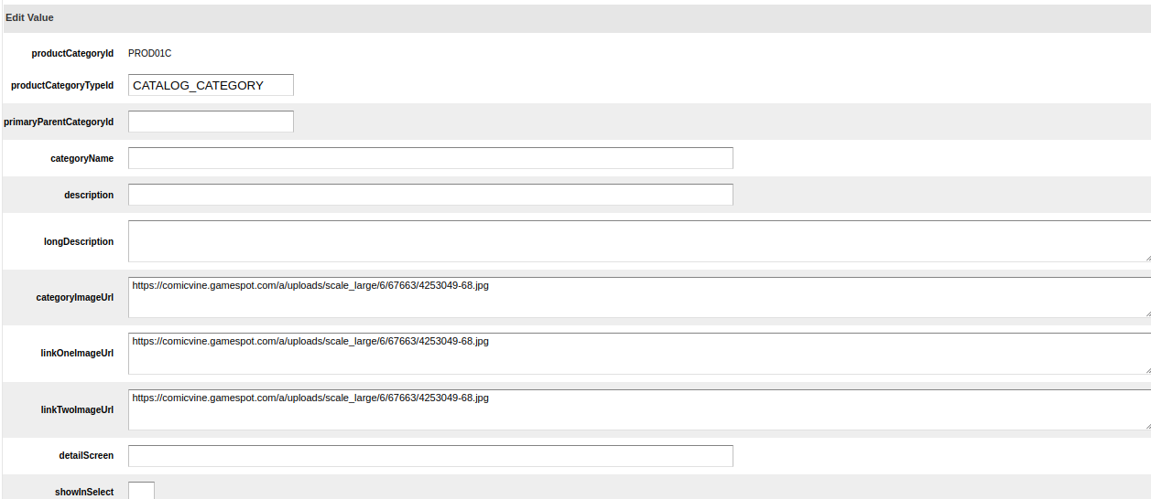

1. Then associate the product with productCategory

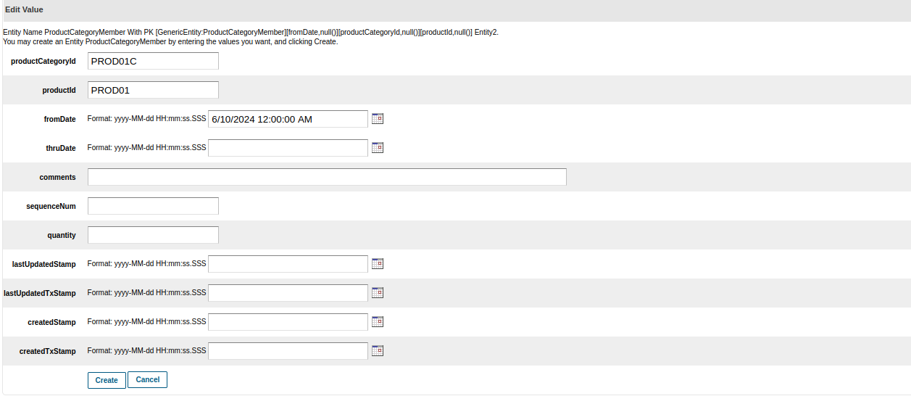

1. After this we create a catalog for product category.

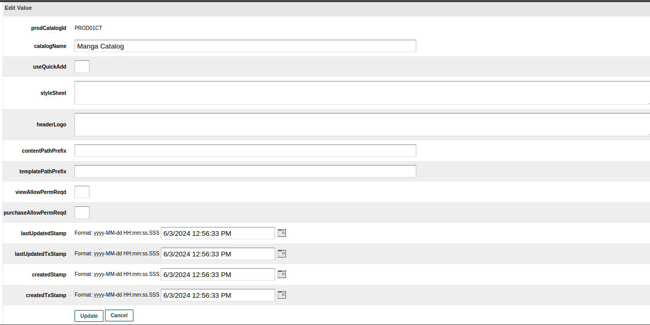

1. Then associate

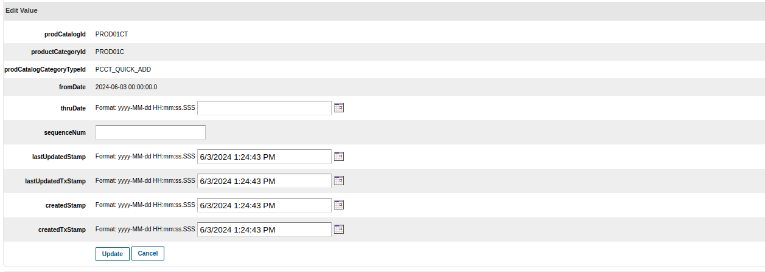

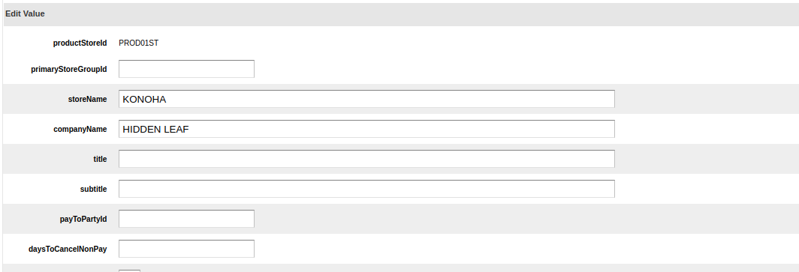

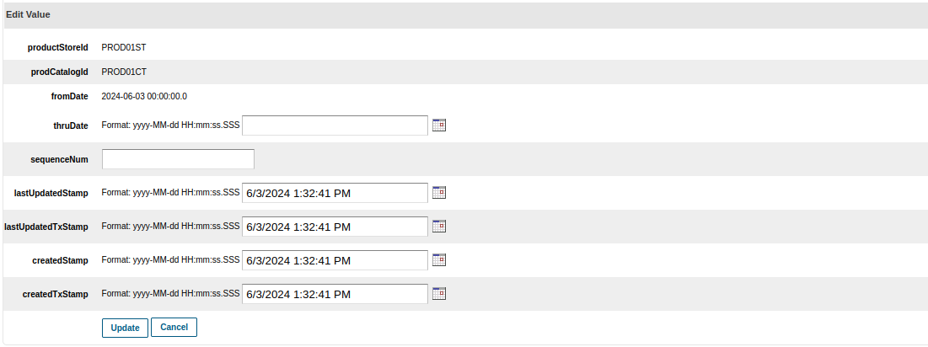

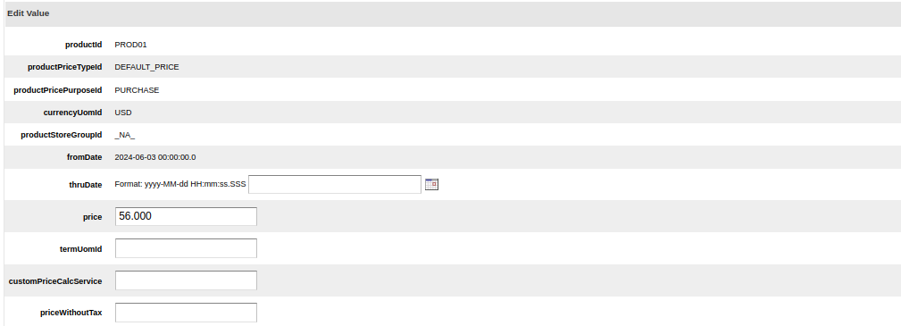

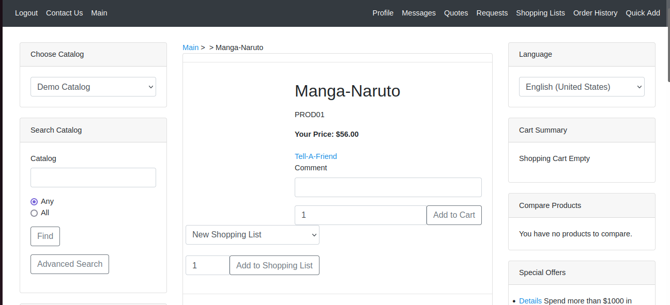

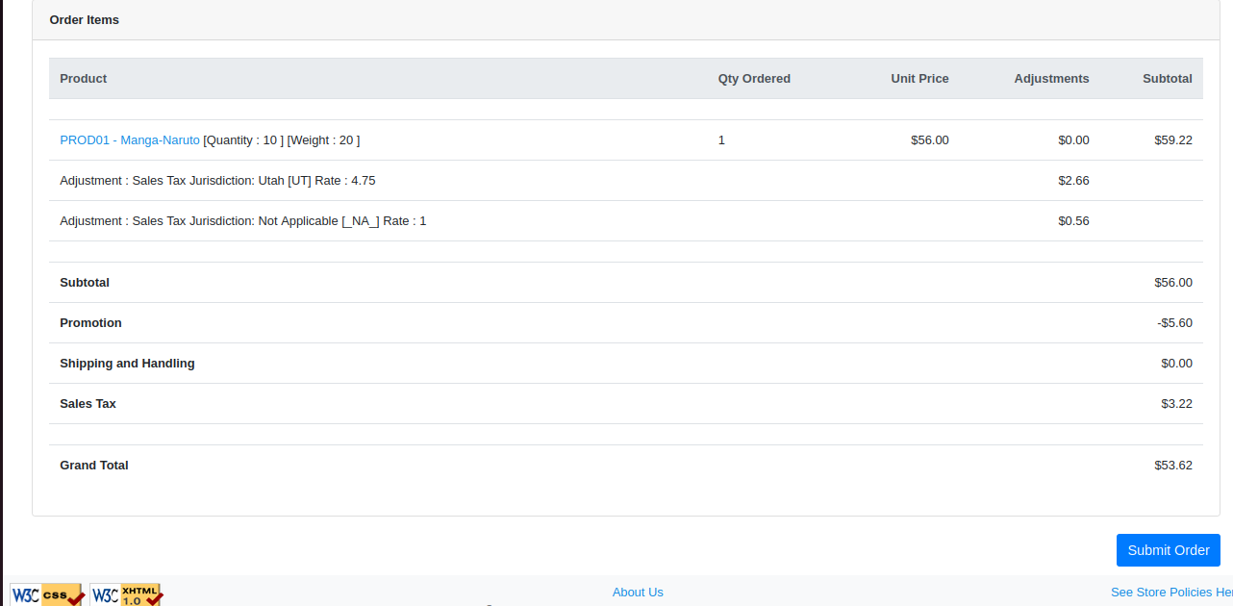

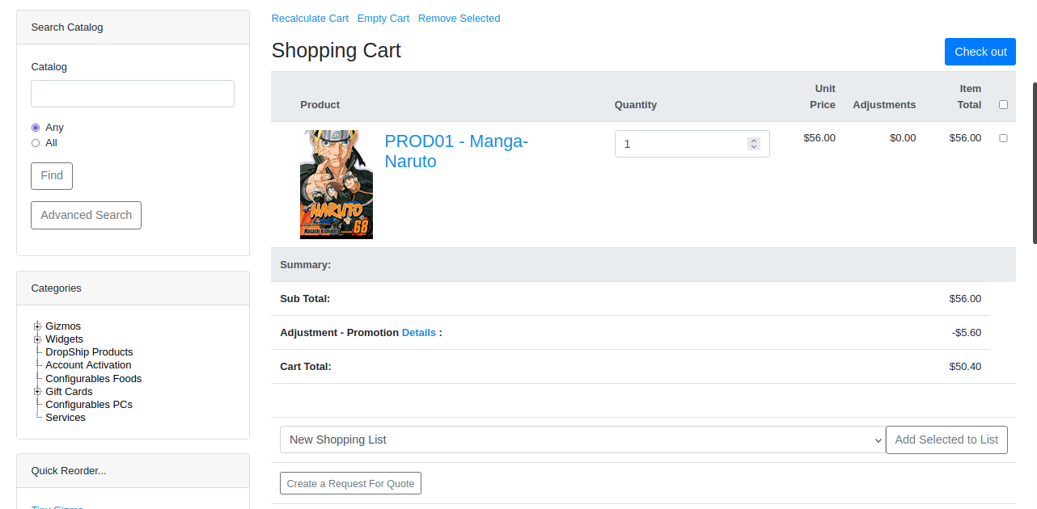

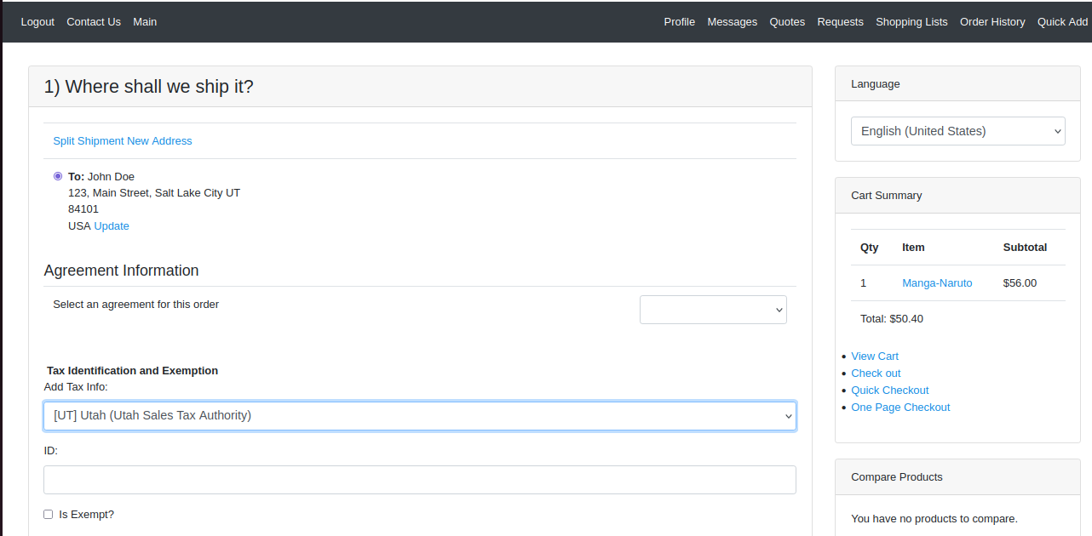

## **Que: Create a product having variants, we can purchase.**

1. Here I’m using Import XML (Web Tool). For creating products and for their association.

